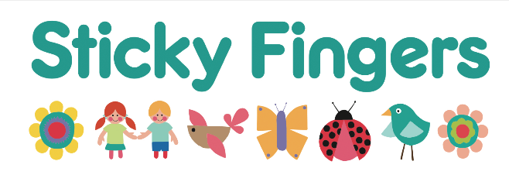 | Registration Form  Please answer ALL questions.  Please print or write clearly.

 |  | Date of Birth
 |  | Day | Month | Year
Child’s Full Name:

Boy or Girl: | Child’s First Language: | Other Languages Spoken:
Ethnicity (Required for “Free Nursery Education Place” grant applications):

Child’s Home Address:

Full Name of Parent /Guardian 1:  Relationship:  Occupation:  Telephone Number 1:  Email 1: |  | Full Name of Parent/Guardian 2:  Relationship:  Occupation:  Telephone Number 2:  Email 2:
Who Has Parental Responsibility?  (please tick all that are applicable) |  | Parent 1:  Parent 2:  Other:
Regular Collection by: |  | Mobile Tel No:
Emergency Contact Name (this could be a friend, a trusted neighbour or a relative):

Tel No: Password:

Brothers and Sisters (please give names and ages)

Permissions

Contact by email: Yes/No Contact by ‘phone: Yes/No Contact by WhatsApp: Yes/No

Photos & videos in perpetuity: Yes/No Photos on website in perpetuity: Yes/No

Staff & Student Observations: Yes/No

Outings to park or library: Yes/No (formal outings will have permission forms at the time)

YOUR CHILD’S MEDICAL DETAILS
Has your child been immunised for the following (please tick ‘Yes’ or ‘No’)
Diphtheria |  | Yes | No
Whooping Cough |  | Yes | No
Polio |  | Yes | No
MMR (measles, mumps, rubella) |  | Yes | No
Is your child an asthma sufferer? |  | Yes | No
Does your child take any medication for asthma? |  | Yes | No
Does your child take medication for any other conditions?
Please state what condition and what medication.

Has your child had their 2-year-old check up?
Child’s doctor or Health Practice: | Doctor’s Telephone No:
Does your child have any food allergies?
Are you in contact with any professionals such as a health visitor, speech therapist, physiotherapist etc?
Do you give your permission for us to share information with health care professionals? YES / NO

Attendance Options
Please tick preferred attendance options
 | Monday | Tuesday | Wednesday | Thursday | Friday
Full Time
(8-6)
Core Time
(9-4)
What starting date do you require?

DECLARATION
I agree to be bound by the terms and conditions.
I also give consent for this child to be given emergency treatment if required.

(Please sign and print your name clearly)
Sign: | Print: | Date:

Please circle your relationship to the child:
Mother Father Guardian Other (Please state)

For BACS payment of £100 non-refundable registration fee:
A/C name: Sticky Fingers Day Nursery Bank Account No: 30608645 Sort Code: 20-90-69 Reference: Child’s full name

